<Tên dự án>
Đặc tả yêu cầu
Mã dự án: <Mã dự án>
Mã tài liệu: Mã dự án_DTYC_x.y

Tp.Hồ Chí Minh, Tháng 7 năm 2011
RECORD OF CHANGES
*T - Thêm S - Sửa X – Xóa

Ngày | Mục thay đổi | T*, S, X | Mô tả thay đổi | Phiên bản | Thành viên
06/09/11 |  | A | Init | 0,1 | DoanNX

Table of Contents
1 GIỚI THIỆU 5
1.1 Mục đích 5
1.2 Phạm vị dự án 5
1.3 Viết tắt 5
1.4 Tham khảo 5
1.5 Cấu trúc tài liệu 6
2 Tổng quan hệ thống 7
2.1 Hệ thống 7
2.2 Yêu cầu chức năng 7
2.3 Yêu cầu khác 8
3 Đặc tả yêu cầu 9
3.1 Yêu cầu chức năng 9
3.1.1 Send Merged SMS(s) function 9
3.1.2 Pick contact(s) from contact list function 10
3.2 Yêu cầu khác 11

List of Figures
Figure 1. System Environment. 7
Figure 2. Use case: Send Merged SMS(s). 9
Figure 3. Use case: Pick contact(s) from contact list. 11

GIỚI THIỆU

Mục đích
The purpose of this document is to present a detailed description of the jASM application. It will define the whole jASM application, and explain the purpose and features of this application, as well as the interfaces of it, what this application will supply, the constraints under which it must operate and how this application will react to external actors. This document is intended for both the stakeholders and the developers of this application.

Phạm vị dự án
This application is an application helps user who is using Android mobile can save his/her time when he/she sends SMSs to his/her friends on the vacations. With this application, user can send multiple SMSs at the same time and still keep the personality characteristic of each SMS, by inserting the own name of receiver in the SMS's content automatically.
This system is intended to develop based on Android OS version 2.1 or higher.

Viết tắt
STT. | Thuật ngữ | Mô tả
1 | SMS | Short Message Service

Tham khảo
STT. | Tài nguyên | Tác giả | Ghi chú
1 | jASM_High level requirement | DoanNX | All document.

Cấu trúc tài liệu
The next chapter, the Overall Description section, of this document gives an overview of the functionality of the product. It describes the informal requirements and is used to establish a context for the technical requirements specification in the next chapter.
The third chapter, Requirements Specification section, of this document is written primarily for the developers and describes in technical terms the details of the functionality of the product.
Both sections of the document describe the same software product in its entirely, but are intended for different audiences.

Tổng quan hệ thống

Hệ thống
This system is an Android application with 3 functions as following:
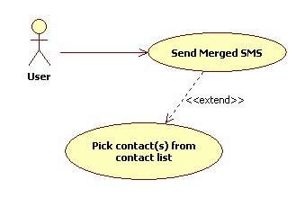
Figure 1. System Environment.

Yêu cầu chức năng
This section outlines the main functions of this application.
As the above diagram, this application includes 2 main functions:
- Send Merged SMS(s): user can create SMS and send to multiple receiver(s) simultaneously, and the name of each receiver (similar to his/her name in contact list or define at this time) will be inserted in the SMS content before sending.
- Pick contact(s) form contact list: user can access the contact list on mobile directly to choose the receiver(s).

Yêu cầu khác
N/A.

Đặc tả yêu cầu

Yêu cầu chức năng

Send Merged SMS(s) function
This function allow user to create and send SMS(s) to the chosen receiver(s).
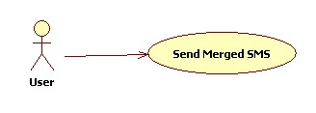
Figure 2. Use case: Send Merged SMS(s).
Use case | Send Merged SMS(s)
Short Description | Guest can use this function to view the information of OOG.
Pre-Conditions | -
Post-Conditions | Merged SMS(s) is sent to receiver(s).
Main Flow | 1. Input the number phone and the name of receiver(s) into To textbox.  2. Input the SMS content into Content textbox.  3. Click the Send button. | 4. System inserts the name of each receiver into the SMS content by replacing the string [name] in the SMS content by the name of receiver.  5. System send SMSs sequencely.
Alternative Flow(s) | 1.1. Choose the receiver from contact list on mobile by clicking the Contact button. | 1.2. System calls the Pick contact(s) from contact list use case.
Example | 1. User inputs: 0122xxxxxx (ABC); 0169xxxxxx (DEF)  2. User inputs: Dear [name]  3. User clicks the Send button. | 4. System will replace sequencely [name] by ABC and DEF before sending.  And ACB will receive one SMS with content: Dear ABC, similarly, DEF will receive one SMS with content: Dear DEF.

Pick contact(s) from contact list function
This function allow user to pick contacts from contact list on mobile and fill them into To text box with the format: phone number (user name)
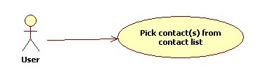
Figure 3. Use case: Pick contact(s) from contact list.
Use case | Pick contact(s) from contact list
Short Description | Pick contacts from contact list on mobile and fill them into To text box.
Pre-Conditions | -
Post-Conditions | The chosen contact(s) will be returned.
Main Flow | 2. User chooses the contact(s).  3. User click on the button OK. | 1. System displays the contact list on mobile.  4. System returns the chosen contact(s).
Alternative Flow(s) | 3.1. User click on the button Cancel. | 3.2. System ends this use case.

Yêu cầu khác

